|  |
| --- |
|  |
|  |

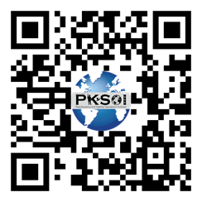**The U.S. Army’s Peacekeeping and Stability Operations Institute Ensure appropriate and accurate Army, Joint, intergovernmental, and multinational stability, security force assistance, and peace operations (SS&PO) capability development and integration across DOTMLPF-P.**

We execute across four lines of effort to ensure DoD, USG, and key partner peace and stability capabilities are continually improved, ready to meet tomorrow's challenges, and fully deliver in support of national objectives.

* **Policy**: Advise & shape policy to ensure SS&PO Policy supports doctrine & training development.
* **Doctrine**: Influence & contribute to concepts; adapt & improve doctrine to meet Army & Joint MDO requirements across the competition continuum.
* **Education**: Develop mutually supporting & scalable education rooted in doctrine, tailored to needs.
* **Training**: Deliver world-class training & warfighter/exercise support, capture lessons learned, prepare operational & strategic leaders, and improve force readiness.

As the U.S. Joint Proponent for Peacekeeping and Stability Operations, and a NATO Partner Training and Education Center, we assist in the development and delivery of a variety of multi-modal training opportunities. We offer focused and expertly delivered instruction to U.S. Army warfighters, the Joint Force and our NATO allies to ensure a common framework and comprehensive understandings of these most critical operations through the following:

**Resident Courses**: Investment in leader development through integrated education opportunities,

**Distance Learning**: Online courses hosted on the Joint Knowledge Online (JKO),

**Mobile Training Teams**: Expertly delivered, tailored, mission focused training upon request.

We are a resource for practitioners, ready and willing to assist in winning and securing the peace.